|  |  |
| --- | --- |
| **ODF Series** | **Optical Distribution Box** |
|  |  |

Welltech Enterprises optical distribution box is a series of products designed for FTTH. Equipped with reliable fiber optic cable, drop cable fixed device, optical fiber splicing protection device and optical splitter installation device ,it is to achieve the distribution and dispatch for fiber. It is suitable for outdoor wall-mounted and pole-mounted and allowed to install the PLC splitter and adapter. Two kinds of materials include engineering plastic and metal are allowed. Plastic series have strong impact resistance, protection class IP55.

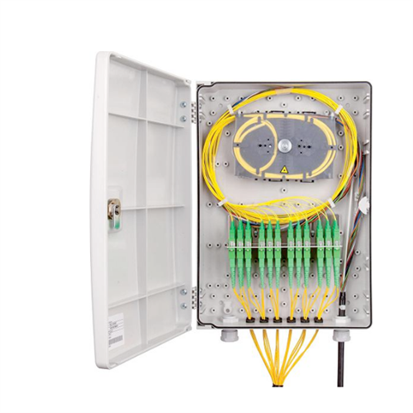

**FEATU**

**FFEATURES**

* **The box adopt high quality flame-retardant material, good leakproof and weather proof performance, applicable to be used for indoor, have wall mount and pole hold for installation, protective grade is IP55 ●Special fixed point for drop cable Suitable for ribbon optical cable or non-ribbon optical fiber**
* **Have special hole for fast connecting drop cable with fast connector can realize connection inside the box terminate cable is easy for operation**
* **Reliable for cable introduction, fixation, stripping and protection , grounding function, max. 1x 2pc outdoor armored cable.**